# **18. VLANs: PART 3**

## **Native VLAN on a Router (ROAS)**

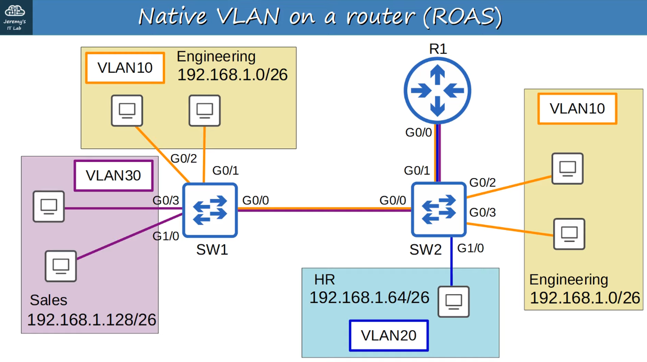

Native VLAN untagged frames are faster and more efficient (smaller) than tagged ones.

### **Reset All Switches to Native VLAN 10**

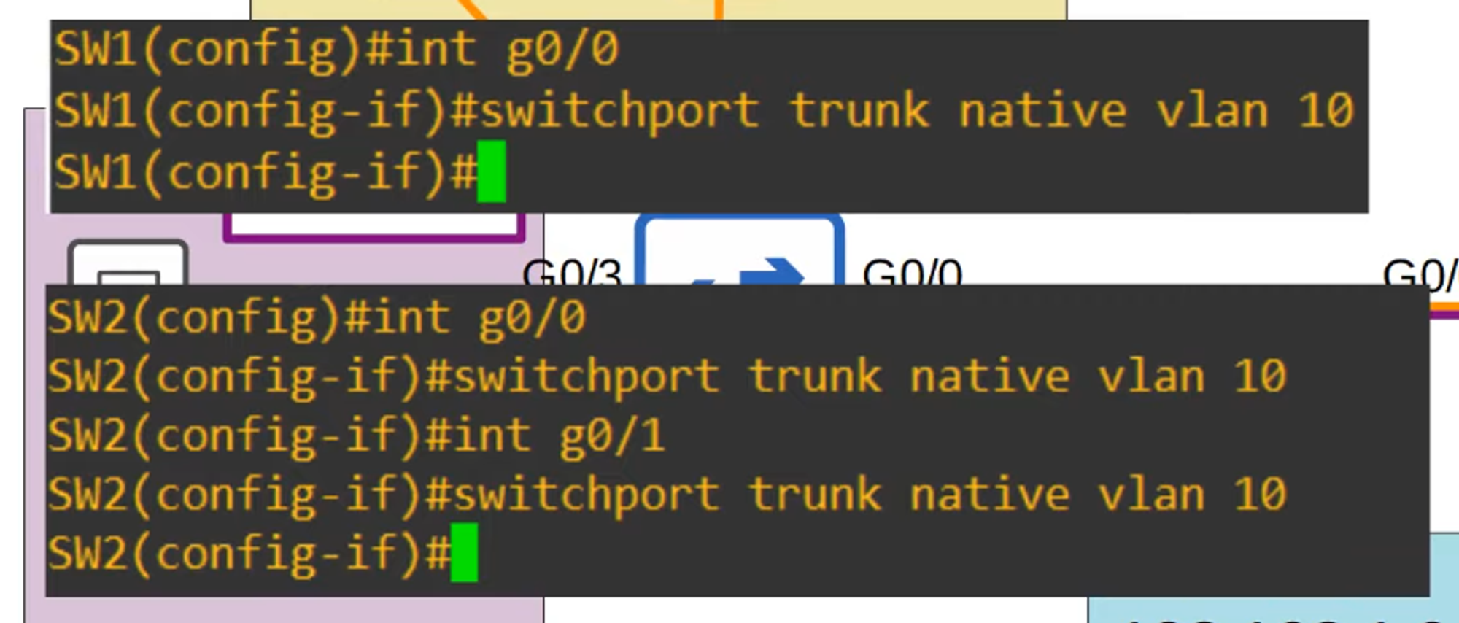

### **Two Methods of Configuring the Native VLAN on a Router:**

1. Use the command encapsulation dot1q <vlan-id> on a Sub-Interface:

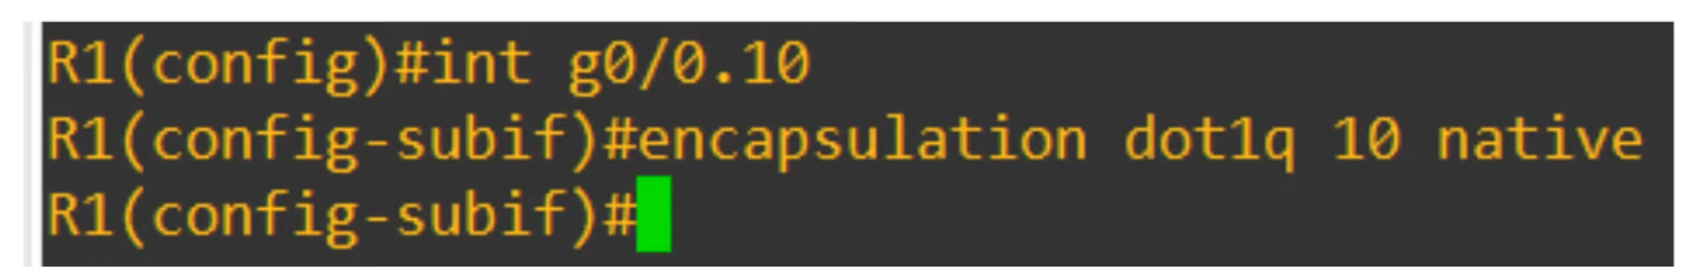

1. Configure the IP address for the native VLAN on the router’s physical interface (the encapsulation dot1q <vlan-id> command is not necessary):

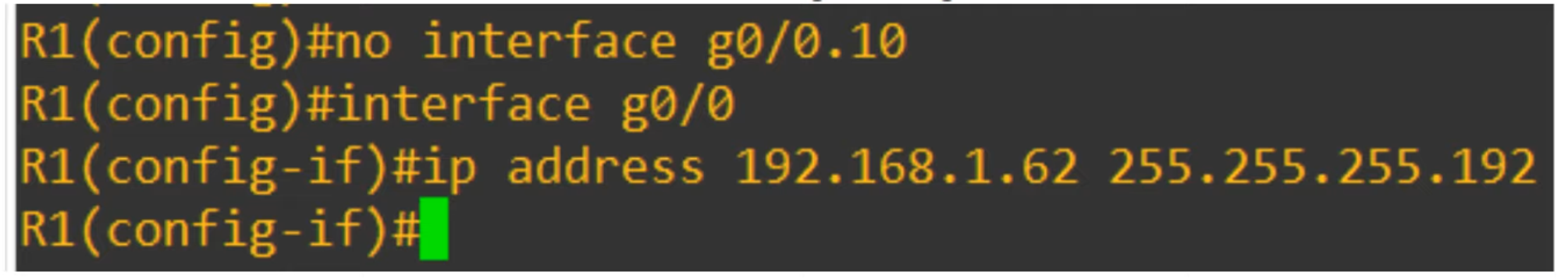

### **Output of show running-config of G0/0 Interface:**

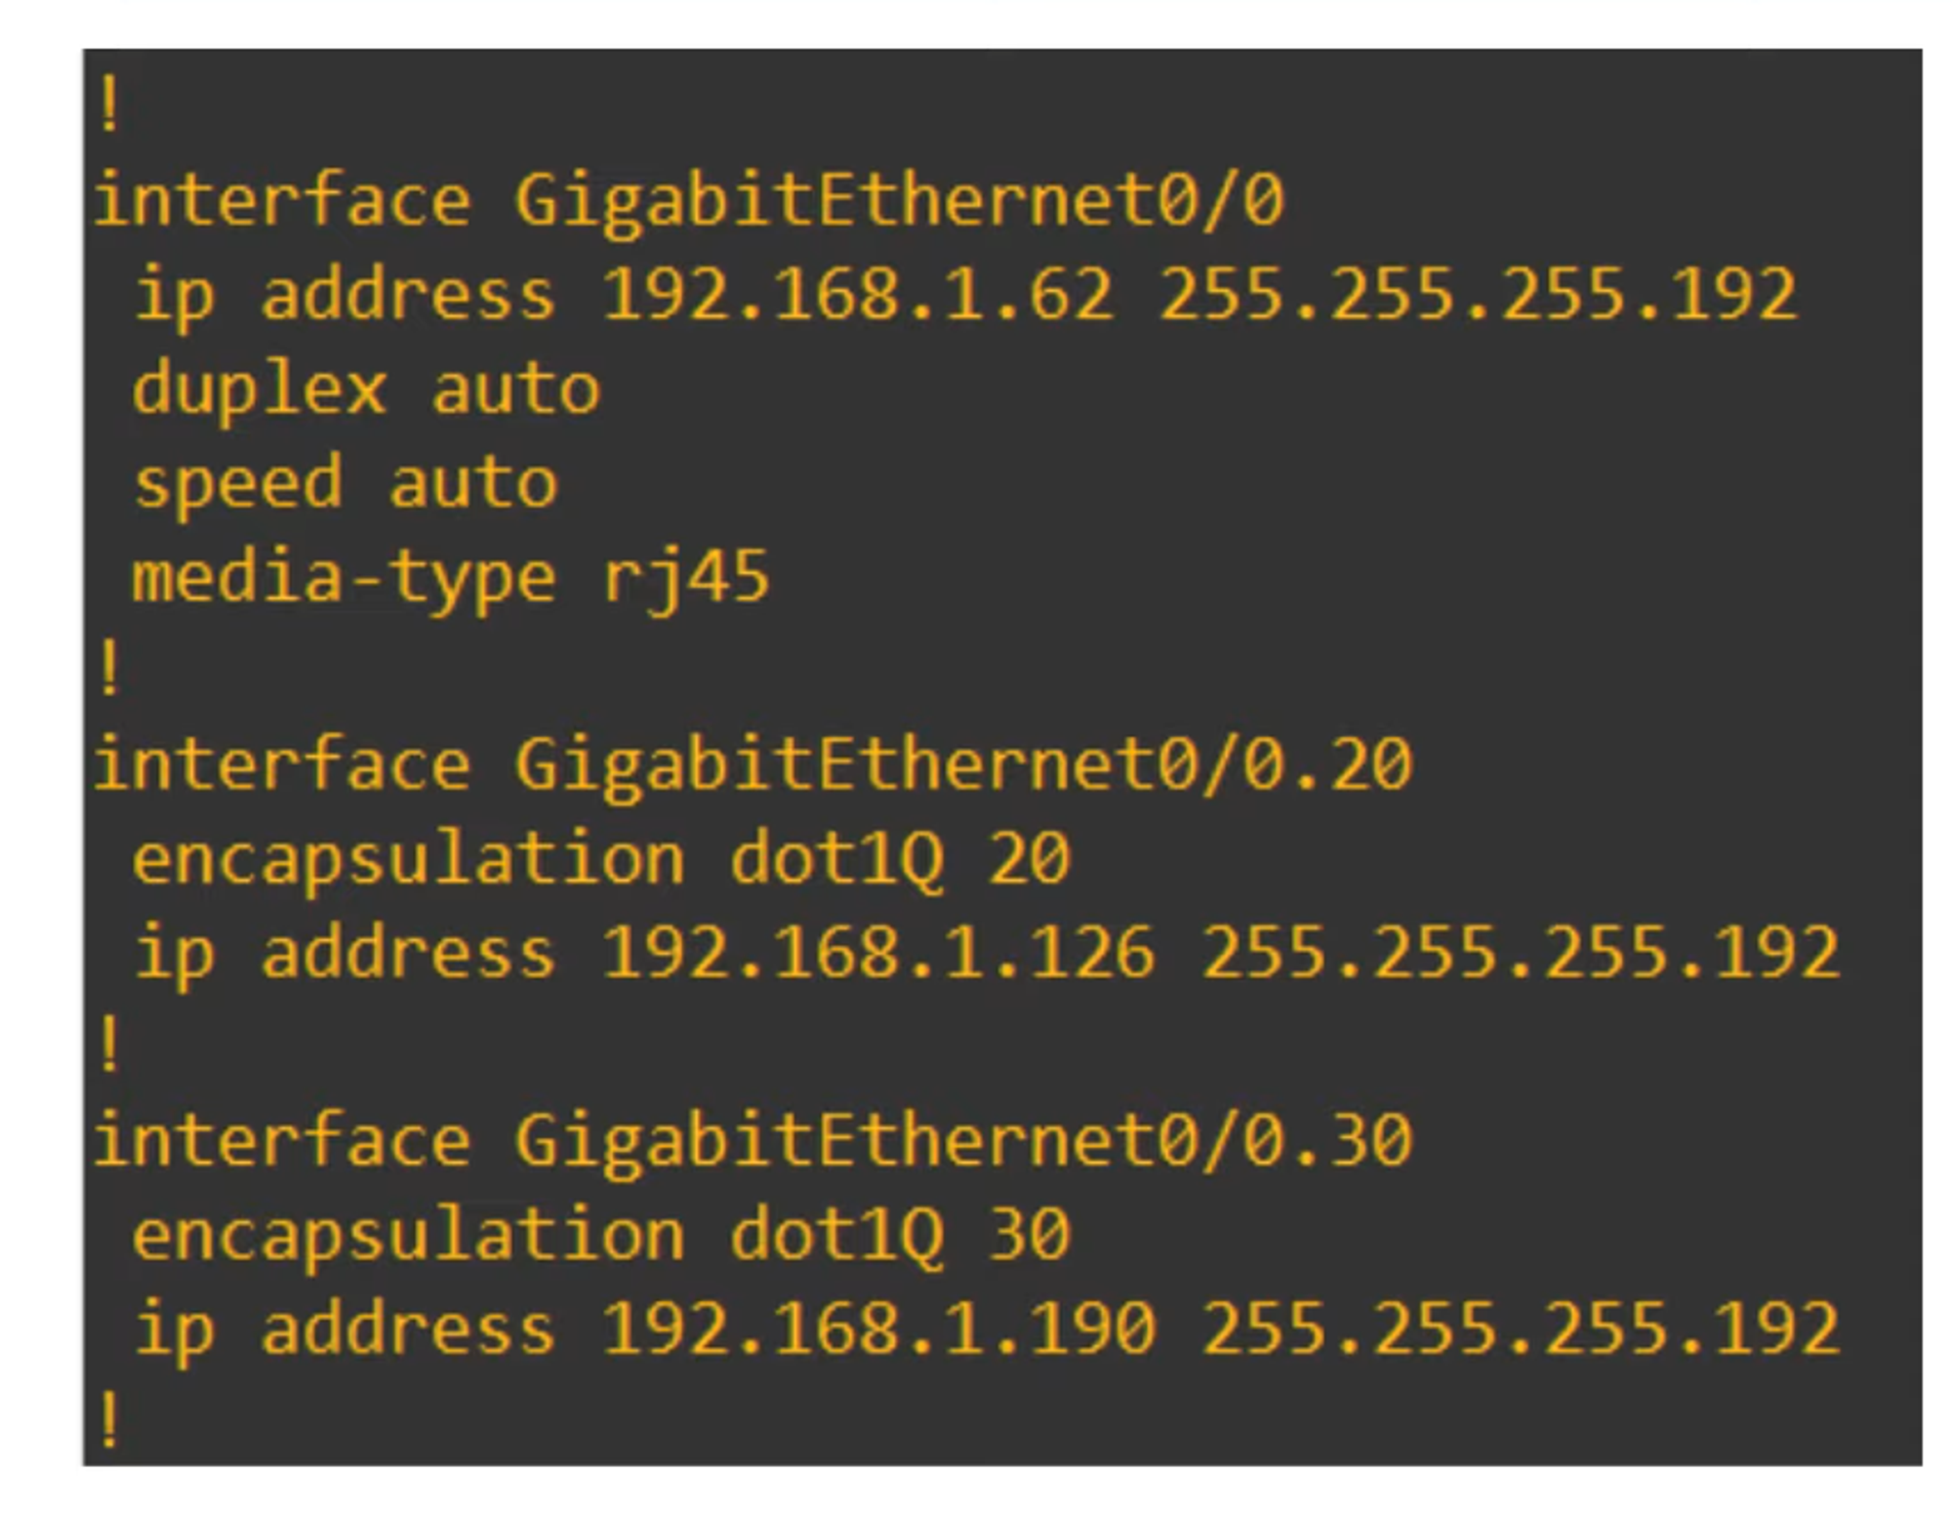

## **Layer 3 (Multilayer) Switches**

### **Icon Appearance:**

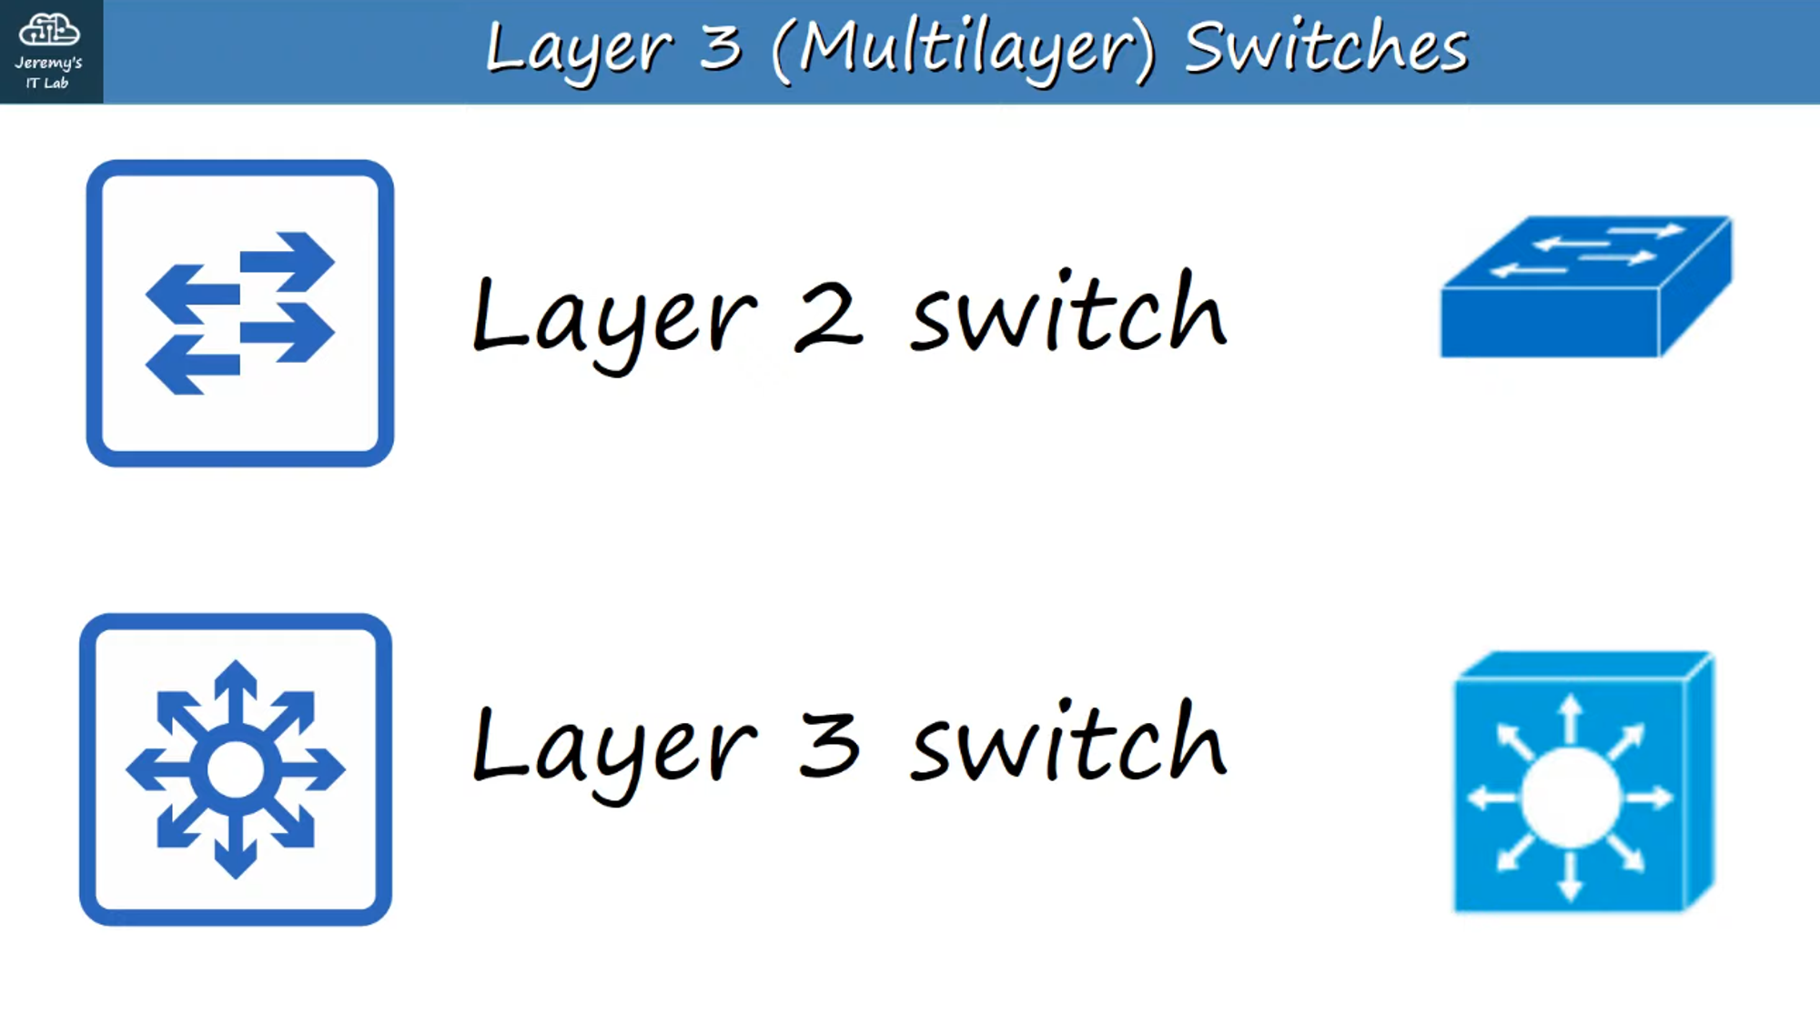

* A multilayer switch is capable of both switching and routing.
* It is Layer 3 aware.
* You can assign IP addresses to its Layer 3 Virtual Interface, like a router.
* You can create virtual interfaces for each VLAN and assign IP addresses to those interfaces.
* You can configure routes on it, just like a router.
* It can be used for inter-VLAN routing.

### **SW2 Replaced with a Layer 3 Switch**

Multi-VLAN connections to R1 are removed and replaced with a point-to-point Layer 3 connection:

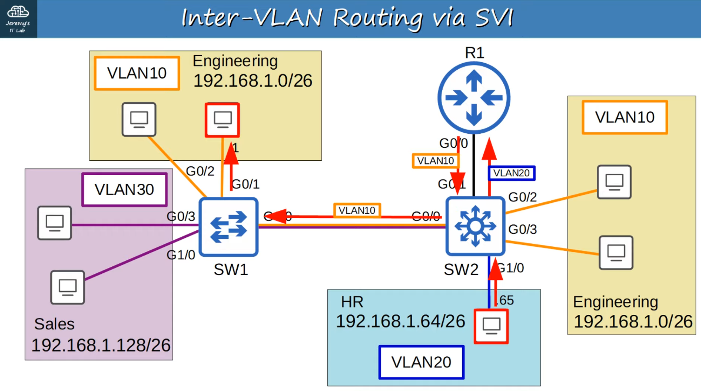

* **SVIs (Switch Virtual Interfaces):** Virtual interfaces on a multilayer switch that can be assigned IP addresses.
* Configure each host to use the SVI (not the router R1) as their gateway address.
* To send traffic to different subnets/VLANs, the PCs send traffic to the switch, and the switch routes the traffic.

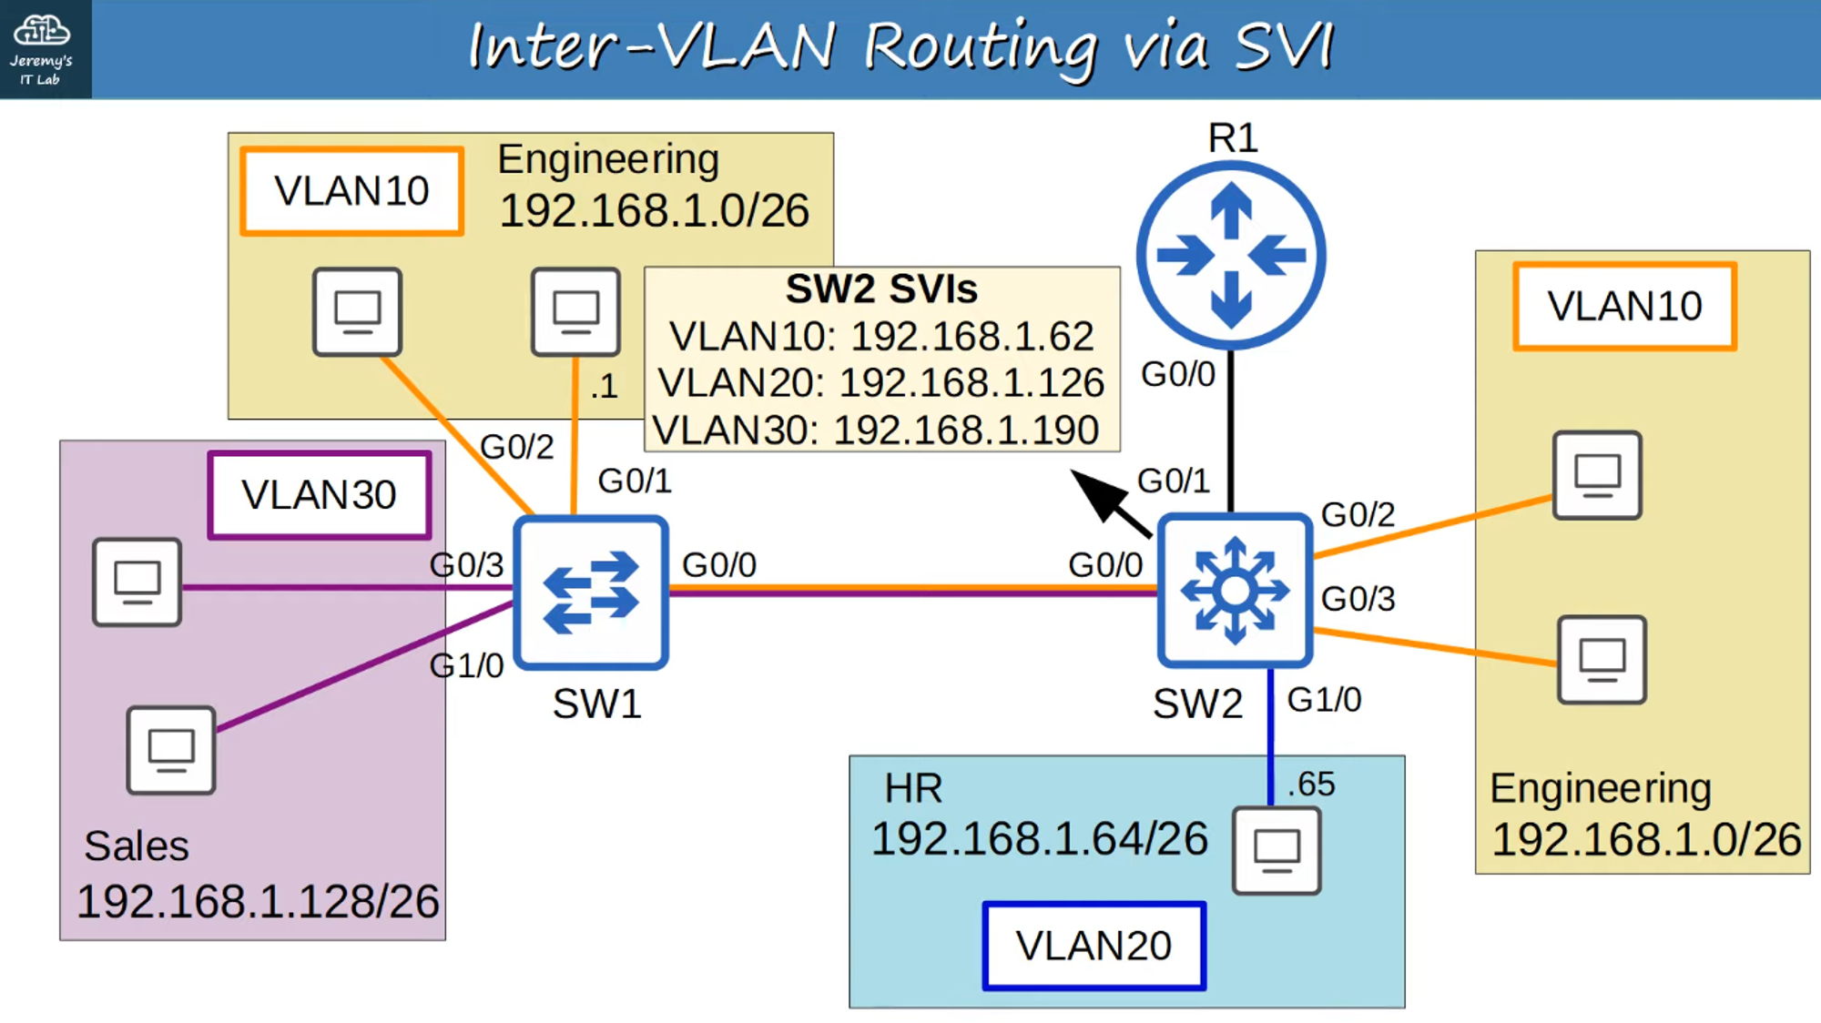

### **Clearing R1 Configuration to Work with the Layer 3 Point-to-Point Connection**

Commands to clear configuration:

1. no interface <sub-interface-id>: Removes the VLAN interface.
2. default interface g0/0: Resets the g0/0 interface to its default settings.

Then configure the default R1 G0/0 interface’s IP address to 192.168.1.194 (as per the network diagram).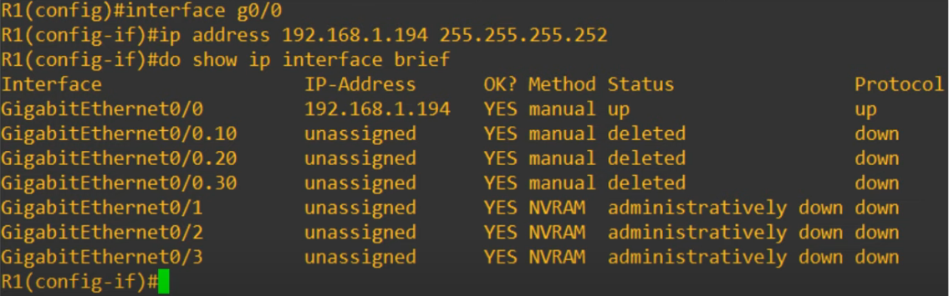

### **Configuration of SW2 to Use SVI and Layer 3 Point-to-Point Connection with R1:**

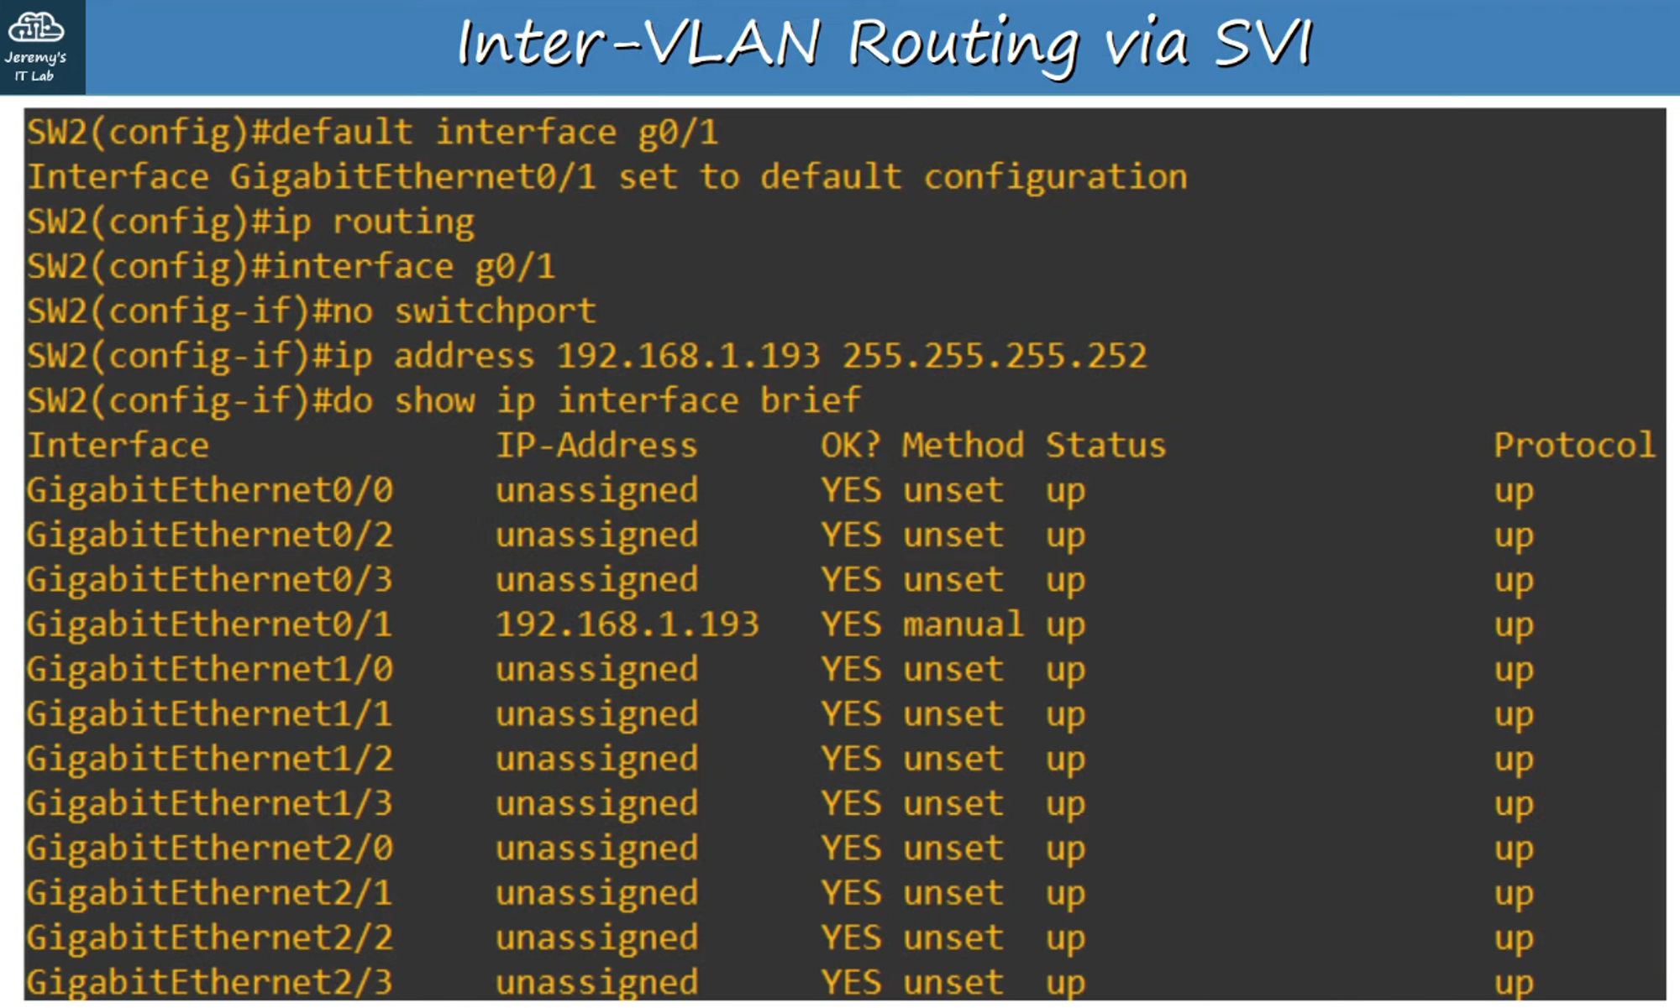

Commands:

1. default interface <interface-id>: Resets settings on the specified interface to defaults.
2. ip routing: **Important** command to enable Layer 3 routing on the switch.
3. no switchport: Configures the interface from a Layer 2 switchport to a Layer 3 "routed port".
4. Sets the default route to R1 (192.168.1.194) so all traffic leaving the network gets routed through R1’s Gateway of Last Resort (Default Gateway).

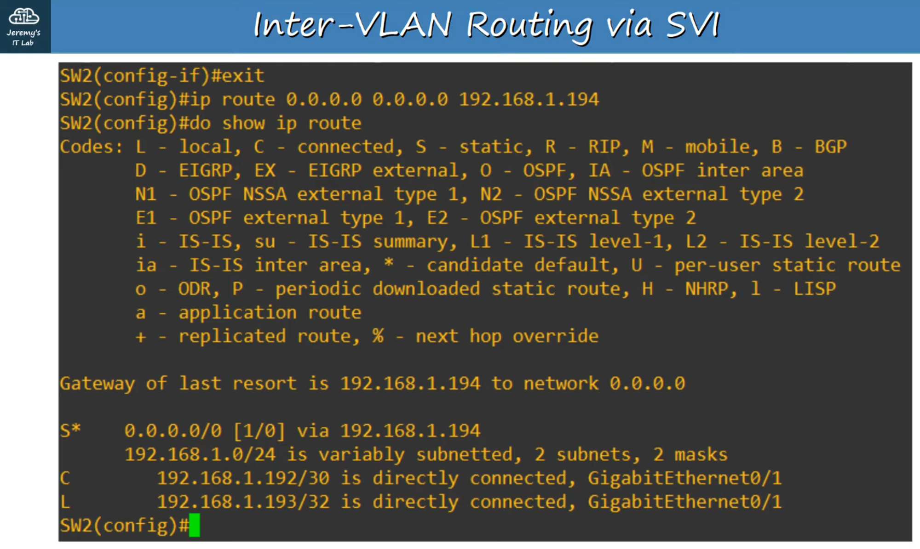

### **SVI Configuration on SW2 (Virtual Layer 3 Routing Interfaces):**

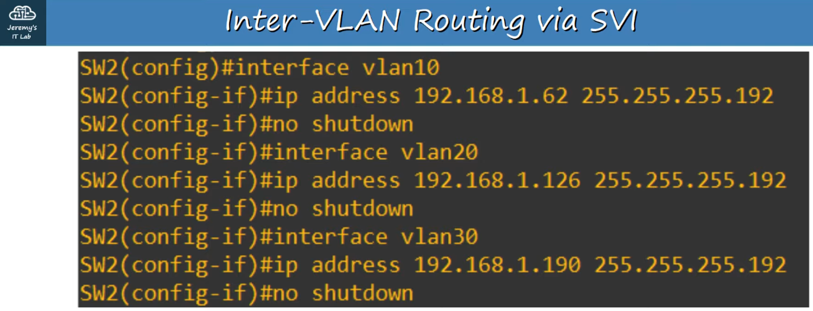

* **SVIs are shut down by default**; remember to use no shutdown.

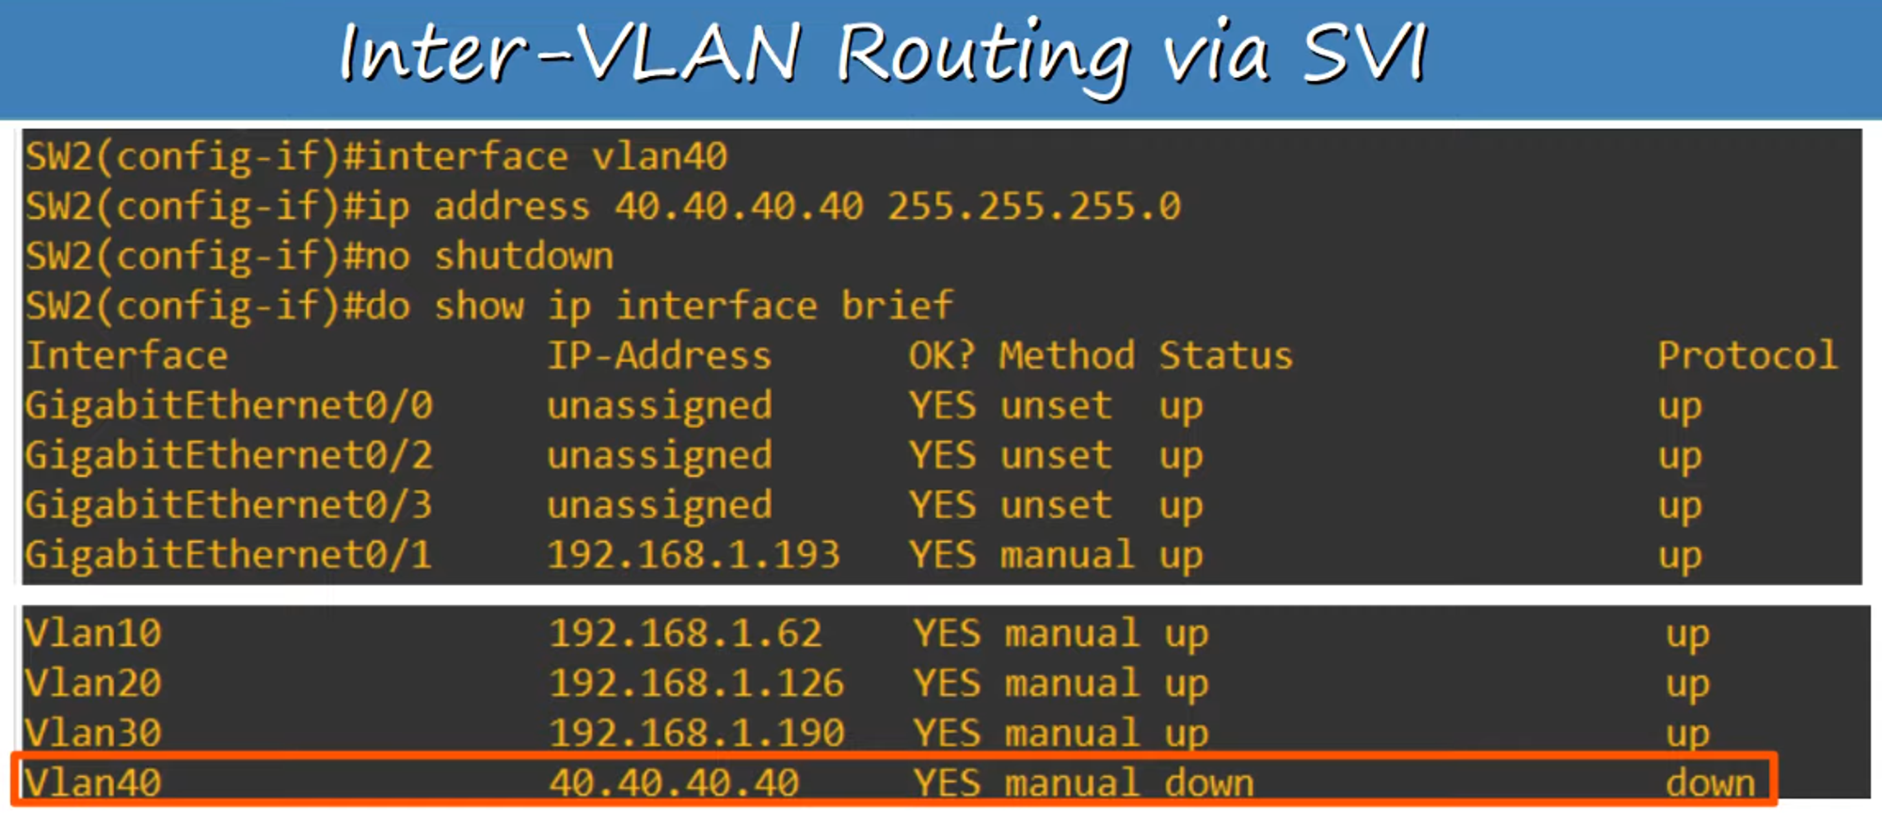

#### **Creating an Unknown SVI (VLAN 40) - Status/Protocol is "down/down"**

Conditions for an SVI to be "up/up":

1. The VLAN must exist on the switch.
2. The switch must have at least one access port in the VLAN in an "up/up" state and/or one trunk port allowing the VLAN in an "up/up" state.
3. The VLAN must not be shutdown (use the shutdown command to disable a VLAN).
4. The SVI must not be shutdown (SVIs are disabled by default).

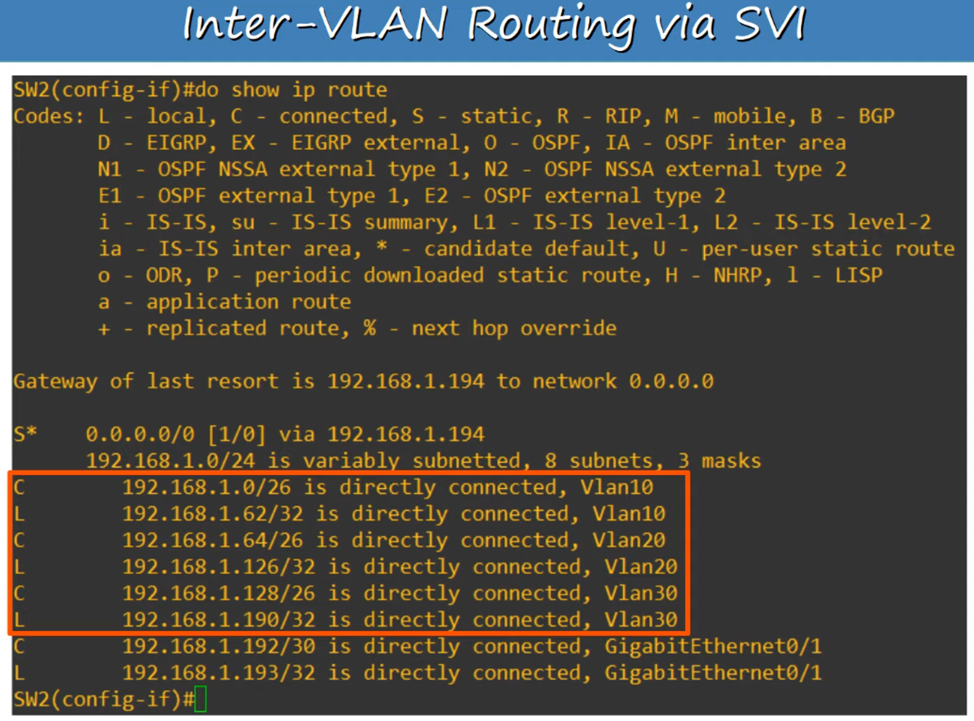

The VLAN trunk has been successfully replaced by a Layer 3 switch SVI. All hosts should be able to connect with each other (tested with ping) and reach the external internet (via the cloud symbol attached to R1).